FY24 Ticket and Participation Subsidy Grant Application
  - Word Document Version – List of Questions
UPDATED: January 18, 2024

THIS IS NOT THE OFFICIAL APPLICATION. TO SUBMIT AN APPLICATION FOR THIS GRANT VISIT http://artsfairfax.submittable.com/submit

* Denotes a required question.

ELIGIBILITY CONTINUED
Upload Required Eligibility Documents*
Upload 3 documents:
- IRS Determination Letter
- Board List with addresses*
- VA Form 102 Remittance for Charitable Organization**
*Include Board members' profession, work address, and place of residence. Highlight members who live or work in Fairfax County.
**This form will be used to verify your organization's physical street address. If you do not have a recent form on file, complete and upload pages 1-3 and 7 (signature page). Form 100 may be submitted for organizations with budgets under $5,000.
VA Form 102: https://www.vdacs.virginia.gov/pdf/oca102registrationstatement.pdf
VA Form 102 info and database: https://www.vdacs.virginia.gov/food-charitable-solicitation.shtml

APPLICANT INFORMATION
Organization Name*
FEIN Number*
Format: 000000000 (nine digits, no dash)
Mailing Address (and Floor/Suite/Apt)*, City*, State*, Zip Code*
Please note that this is the address that will be used for all grants correspondence.
Is this mailing address the same as your physical address? If not, please complete the following fields for your physical location. *
Yes or No
Physical Street Address (and Floor/Suite/Apt)*, City, State, Zip Code*
P.O. Boxes will not be accepted. "Primary address" means the bona fide physical street address of the organization as specified on page 2 of the VA Form 102 Remittance for Charitable Organization.
Pursuant to §57-49.2 of the Code of Virginia, if the organization does not maintain an office, use the address of the person having custody of its financial records.
Select the appropriate Fairfax County magisterial district or independent city for your organization's street address.*
- Braddock
- Dranesville
- Hunter Mill
- Franconia
- Mason
- Mount Vernon
- Providence
- Springfield
- Sully
- City of Fairfax
- City of Falls Church
Phone Number*
Website*
Social Media
List handles or links to social media channels such as Facebook, Instagram, Twitter, YouTube, LinkedIn, Flickr, Vimeo, TikTok, Tumblr, SoundCloud, Bandcamp, etc.
Grant Contact Name*, Email*, Phone Number*
Chief Administrator Name*, Email*, Phone Number*
Board Chair Name*, Email*, Phone Number*

PROGRAM OVERVIEW
Criteria
- Underserved Audience is well documented and majority Fairfax County based.
  - Underserved refers to populations who face barriers in accessing the arts, and includes populations underserved because of geographic location, religion, sexual orientation, gender identity, underserved racial and ethnic populations, and populations underserved because of special needs (such as language barriers, disabilities, immigration status, or age).
  - Seniors, students, and veterans are not all necessarily underserved. Please provide additional demographics such as low income, disability, and residing in an under-resourced area of the county.
- Marketing Plan is realistic.
  - Includes confirmation of interest from target audience and/or community programs

Proposed Program Date(s)*
Programs spanning multiple dates is considered one singular program. Programs must take place before June 30, 2024.
Please List the anticipated location(s) of your program.
Community Partner Organization(s) Type (Check all that apply)*
- Child Care Center
- Teen Center
- Senior Center
- Community Center
- Faith Based Organization
- School
- Affordable Housing
- Homeless or Emergency Shelter
- Veteran Services
- Human Services
- Assisted Living, Memory Care, or Adult Day
- Health and Wellness
- Other
Name of Community Partner Organization(s)*
Program Name*
1. Program Description*
Where is the program taking place? What activities will be available? Who are the artists, performers, teaching artists?
Suggested word count: 100
2. How will your audience/participants access transportation for this program?*
Suggested word count: 100
3. Who are the audience/participant targets for this program? *
Discuss why you chose this target audience/partnership including why the audience is considered underserved. Include demographics of the target audience such as median income and/or free and reduced lunch statistics. How will this audience benefit from this program?
Refer to the following in your response:
• Diversity is all the ways people differ including age, race, color, sex, sexual orientation, gender identity, religion, national origin, marital status, disability, socio-economic status, neighborhood of residence, and other characteristics.
• Equity is fairness and justice in programming and policy that results in all residents having opportunity to fully participate.
• Inclusion is the act of creating environments ere everyone feels welcomed, respected, and valued.
• Access is a measure of how easily someone can participate including physical, social, and economic barriers.
• Underserved refers to populations who face barriers in accessing the arts, and includes populations underserved because of geographic location, religion, sexual orientation, gender identity, underserved racial and ethnic populations, and populations underserved because of special needs (such as language barriers, disabilities, alienage status, or age).
**** seniors, students, and veterans are not all necessarily underserved. Please provide additional demographics such as low income, disability, and residing in an under-resourced are of the county.
Suggested word count: 200
4. Describe your outreach and partnerships to the target community or communities. *
What steps have you taken to outreach to the target participants? Has the community partner confirmed interest? Is this a new or existing partnership, and if pre-existing describe previous successes. Did you use the NCS/FCPS/FCDOT contacts in the Ticket Subsidy Grant resources?
5. How many are being served? What is the cost per person for eligible expenses (ticket price, tuition, transportation, etc.)? Please provide the breakdown by audience demographics (student, senior …).*
To find the Magisterial District for an event location, please use the Fairfax County My Neighborhood site.
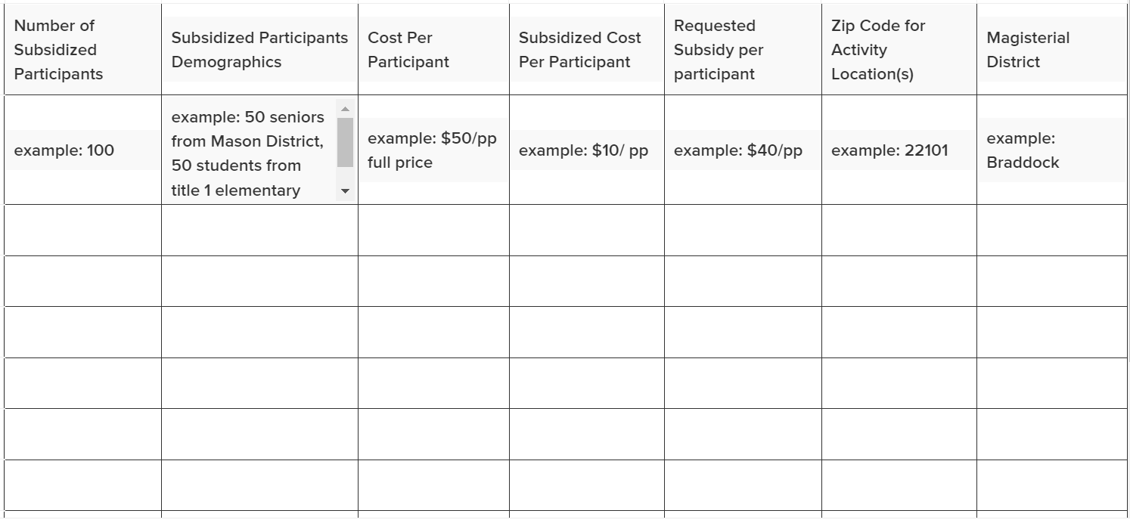

Amount Requested (up to $5,000)*
Eligible Expenses:
- Ticket value (free or reduced price).
- Fees/Tuition for classes, workshops, camps.
- Transportation expenses.
If you have already received one ArtsFairfax Ticket and Participation Subsidy Grant award during FY24 (July 1, 2023 - June 30, 2024), what was the amount of your award?
The combined total funds awarded over two grants may not exceed $5,000 during FY24 (July 1, 2023 - June 30, 2024).
(Optional) Upload Support Documents
Support documents may include letters of support, documentation of partnerships or outreach, breakdown of costs, expenses, etc. Upload up to 3 (optional).
6. (Optional) What else would you like us to know about this program?
Suggested Word Count: 150
How did you hear about this grant?*
- ArtsFairfax Website
- ArtsFairfax Staff
- Social Media
- Fairfax County Human Services Partner Organization
- Email
- Other
Upload Checklist*
- IRS Letter of Determination
- Board List with Addresses
- VA Form 102
Date of Submission*

You have reached the end of the application.

THIS IS NOT THE OFFICIAL APPLICATION. TO SUBMIT AN APPLICATION FOR THIS GRANT VISIT http://artsfairfax.submittable.com/submit

